STUDENT NAME : TOUFEEQ AHMED
ROLL. NO : 25K-6551
SECTION : BSCE-2B
Task 1:
Scenario
A university allows students to sit in exams only if attendance is 75% or above.

Code:
#include<stdio.h>
int main (){
int n;
printf("enter attendance percentage");
scanf("%d", &n);

if(n>=75)
{printf("Eligible to sit in exam");
}
else
printf("Not eligible");
return 0;

}

Output:
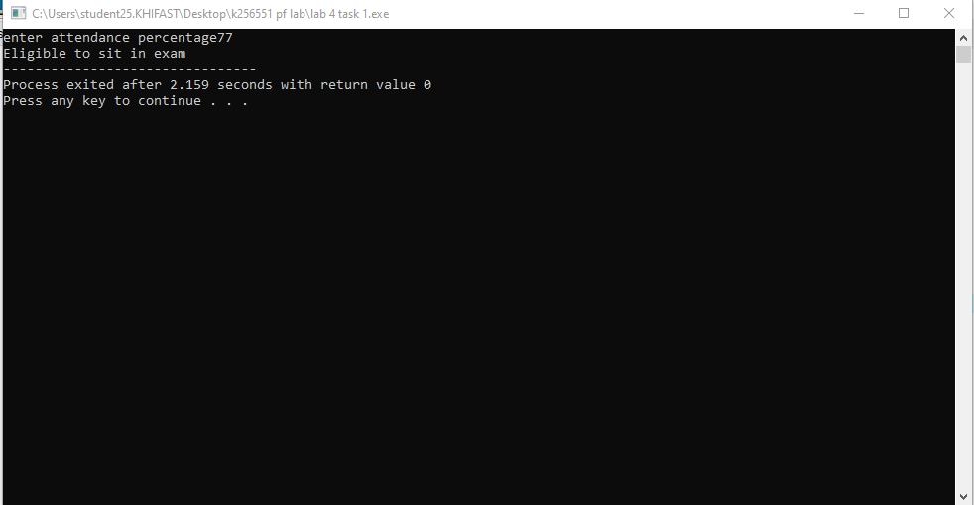

Task 2 :
Scenario
An electricity company classifies users based on electricity consumption.
• Input: total units consumed
• Conditions:
➢ Units ≤ 100 → Low Usage
➢ Units 101–300 → Medium Usage
➢ Units > 300 → High Usage

Code:
#include<stdio.h>
int main (){
int n;
printf("enter the units comnsumed");
scanf("%d", &n);

if(n<=100)
{
printf("Low usage");
}

else if(n>=100 && n<=300) {

printf("Medium usage");

}

else
printf("HIGH USAGE");
return 0;

}

Output:
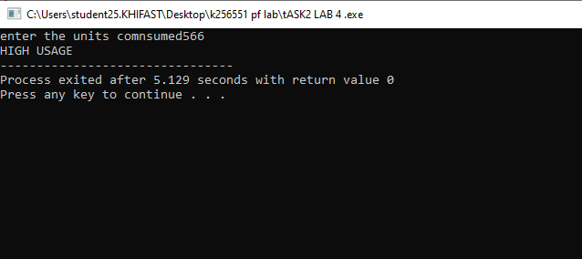

Task 3:
Scenario
A number analysis system determines the type of number entered by the user.
Requirements
• Input: an integer
• Number > 0 → Positive
• Number < 0 → Negative
• Number = 0 → Zero

CODE:
#include<stdio.h>
int main (){
int n;
printf("Enter a number");
scanf("%d", &n);
if(n>0)
{
printf("positive");
}
else if(n<0) {
printf("Negative");
}
else
printf("zero!");
return 0;
}

OUTPUT:
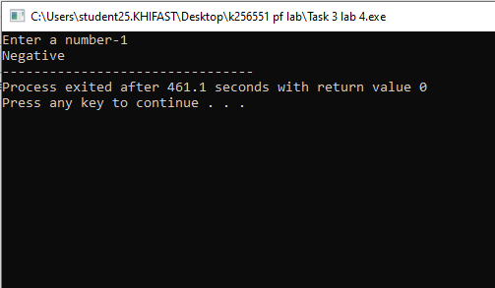

Task 4:
Scenario
A simple login system verifies user credentials.
Requirements
• Predefined credentials:
➢ Username: admin
➢ Password: 1234
• Input username and password
• If both match → Login Successful
• Else → Invalid Credentials

CODE:
#include <stdio.h>
#include <string.h>

int main()
{
int n;
char username[20];

printf("Enter username: ");
scanf("%s", username);

if (strcmp(username, "admin") == 0)
{
printf("Enter password: ");
scanf("%d", &n);

if (n == 1234)
{
printf("Access granted");
}
else
{
printf("INVALID CREDENTIALS");
}
}
else
{
printf("INVALID CREDENTIALS");
}

return 0;
}
OUTPUT :

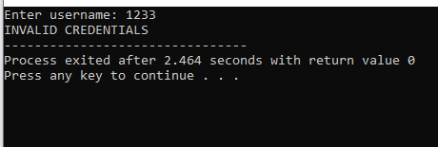

TASK 5:
Scenario
An ATM machine allows users to select different services.
Menu
1. Balance Inquiry
2. Cash Withdrawal
3. Deposit
4. Exit
Requirements
• Input user choice
• Use switch to display relevant message
• Handle invalid choice using default
Concept Used
switch statement

CODE :
#include <stdio.h>

int main() {
int choice;

// Display ATM Menu
printf("ATM Menu\n");
printf("1. Balance Inquiry\n");
printf("2. Cash Withdrawal\n");
printf("3. Deposit\n");
printf("4. Exit\n");

// Input user choice
printf("Enter your choice: ");
scanf("%d", &choice);

// Switch statement
switch (choice) {
case 1:
printf("You selected Balance Inquiry.\n");
break;
case 2:
printf("You selected Cash Withdrawal.\n");
break;
case 3:
printf("You selected Deposit.\n");
break;
case 4:
printf("Thank you for using the ATM. Goodbye!\n");
break;
default:
printf("Invalid choice! Please select a valid option.\n");
}

return 0;
}

OUTPUT :

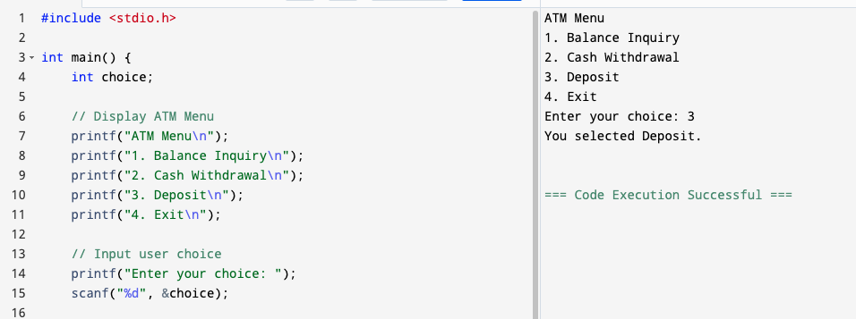

TASK 6 :
Scenario
A grading system assigns grades based on marks obtained.
Requirements
• Input marks (0–100) => (any 5 subjects marks)
• percentage ≥ 85 → Grade A
• percentage ≥ 70 → Grade B
• percentage ≥ 50 → Grade C
• percentage < 50 → Fail
Concept Used
if – else if – else
CODE :
#include <stdio.h>

int main() {
int marks;
float percentage;
printf("Enter marks obtained in 5 subjects");
scanf("%d" , &marks);
percentage = ((marks/500.0)*100);
printf("%f" ,percentage);
if (percentage>=85){
printf("\nGrade A");
}
else if (percentage>=70){
printf("\nGrade B");
}
else if (percentage>=50){
printf("\nGrade C");
}
else
printf("\nFAIL !");
return 0;
}

OUTPUT :
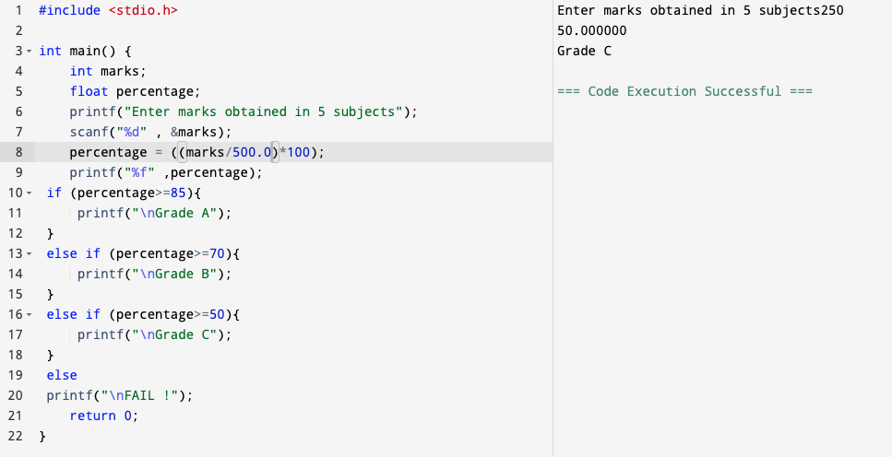

TASK 7:
Scenario
A shopping store offers discounts based on total purchase amount.
Requirements
• Input total bill amount
• ≥ 5000 → 20% discount
• ≥ 3000 → 10% discount
• < 3000 → No discount
Concept Used
if – else if – else
CODE :

#include <stdio.h>

int main() {
int amount;
int total;
printf("Enter the bill amount");
scanf("%d", & amount);
if (amount>=5000){
total = (amount - (amount * 20 / 100.0));
printf("your total is %d ",total);
}
else if (amount>=3000){
total = (amount - (amount * 10 / 100.0));
printf("your total is %d ",total);}
else
printf("sorry you got no discount");
return 0;
}
OUTPUT :
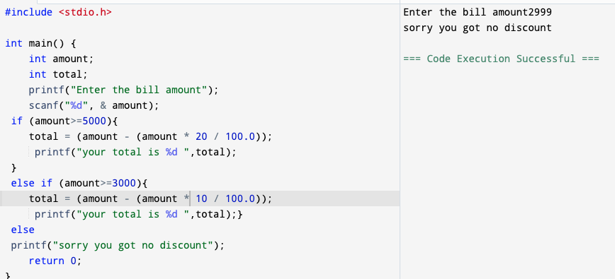
TASK 8 :
Scenario
A scientific calculator performs arithmetic and basic scientific operations based on user
selection.
Menu
1. Addition
2. Subtraction
3. Multiplication
4. Division
5. Square of a number
6. Cube of a number
7. Square Root of a number
8. Power (xy)
9. Absolute Value
CODE :
#include <stdio.h>
#include <math.h>

int main() {
int choice;
float a, b;

// Display Menu
printf("Scientific Calculator Menu\n");
printf("1. Addition\n");
printf("2. Subtraction\n");
printf("3. Multiplication\n");
printf("4. Division\n");
printf("5. Square of a number\n");
printf("6. Cube of a number\n");
printf("7. Square Root of a number\n");
printf("8. Power (x^y)\n");
printf("9. Absolute Value\n");

// Input user choice
printf("Enter your choice: ");
scanf("%d", &choice);

switch (choice) {

// Options 1–4 → two numbers
case 1:
printf("Enter two numbers: ");
scanf("%f %f", &a, &b);
printf("Result = %.2f", a + b);
break;

case 2:
printf("Enter two numbers: ");
scanf("%f %f", &a, &b);
printf("Result = %.2f", a - b);
break;

case 3:
printf("Enter two numbers: ");
scanf("%f %f", &a, &b);
printf("Result = %.2f", a * b);
break;

case 4:
printf("Enter two numbers: ");
scanf("%f %f", &a, &b);
if (b != 0)
printf("Result = %.2f", a / b);
else
printf("Error: Division by zero not allowed");
break;

// Options 5–7 → one number
case 5:
printf("Enter a number: ");
scanf("%f", &a);
printf("Square = %.2f", a * a);
break;

case 6:
printf("Enter a number: ");
scanf("%f", &a);
printf("Cube = %.2f", a * a * a);
break;

case 7:
printf("Enter a number: ");
scanf("%f", &a);
if (a >= 0)
printf("Square Root = %.2f", sqrt(a));
else
printf("Error: Square root of negative number");
break;

// Option 8 → two numbers
case 8:
printf("Enter base and exponent: ");
scanf("%f %f", &a, &b);
printf("Result = %.2f", pow(a, b));
break;

// Option 9 → one number
case 9:
printf("Enter a number: ");
scanf("%f", &a);
printf("Absolute Value = %.2f", fabs(a));
break;

// Invalid choice
default:
printf("Invalid menu choice");
}

return 0;
}
OUTPUT :
